BENNY PARK

FAMILY PICNIC
(Information 514-872-6055)

1pm – 10 pm

BBQ, Picnic, Inflable Games, Animation

1 pm

Craft Tents, Face Painting, Chalk Drawing

3 pm

Quebec Flag Cake

Official Ceremony, Free Flags, Ballons, Music

3:30 pm
Performance by ‘M.T.L.’
4 pm – 8 pm

BBQ, Picnic, Inflable Games, Animation
20h00
Magic show
Movie in the Park - ‘Le Lorax’ (French)

 | NDG  OUTING & SPORTS  CLUB | 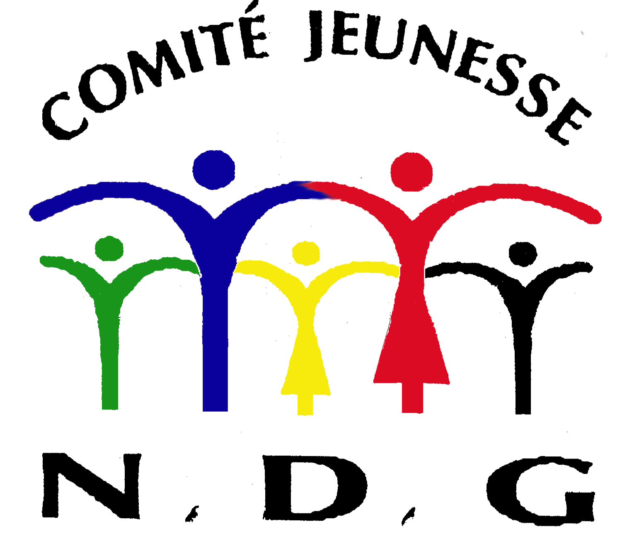

www.centrebenny.org

